|  |  |
| --- | --- |
| Course Name | ITD 1253-60438 |
| Instructor | Prof. Darin McCammon |
| Student Name | Kyle Campbell |
| Due date | 7 Nov 2021 |
| Grade | 50/50 |
| Grading Comments | |  |  | | --- | --- | | There is not a screenshot for the Fibonacci 75. I did mine using recursion and even with a Ryzen-7 2700 Threadripper CPU and 64 GB of DDR4-3866 RAM it was still timing out. | Kyle Campbell, Nov 7 at 11am | | Good for me. | Darin McCammon, Nov 15 at 8:45pm | |

Designer - Screenshot 1 – Controls added and positioned

Deseigner – Screenshot 2 – Controls Sized and Named

Designer – Screenshot 3 – Final Layout and Custom Design

Form Completed and Running – This is a combination of both steps

Processes – Screenshot

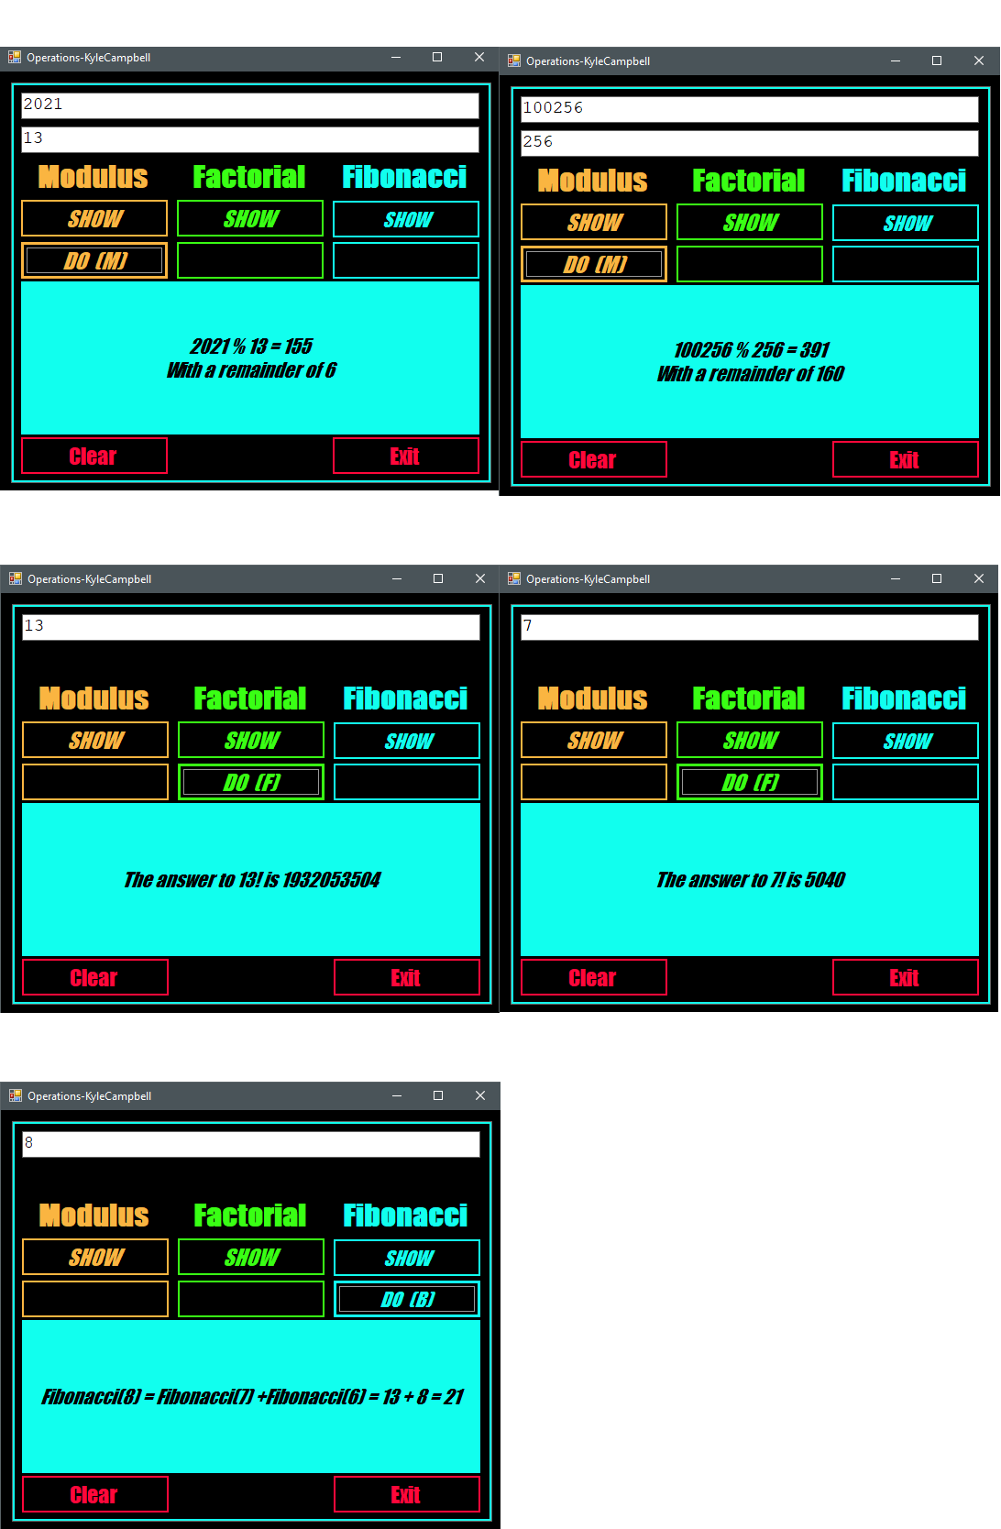

Modulus Screenshot 1